8.2

In Runge-Kutta method, the average slope is approximated as 1/6*(k1+2k2+2k3+k4).

Please see the codes for details.

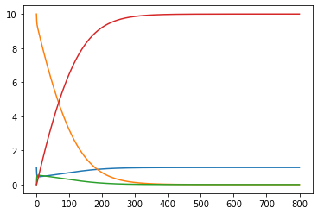

**Red: Product;**

**Yellow: Substrate;**

**Blue: Enzyme;**

**Green: Enzyme-Substrate Complex.**

8.3

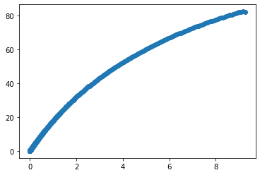

Vm = 80